THE TITANS CUP  PROPERTY FACT SHEET · INVITATIONAL 2025 · GOLS PARTNERSHIPS — WEEK 1
  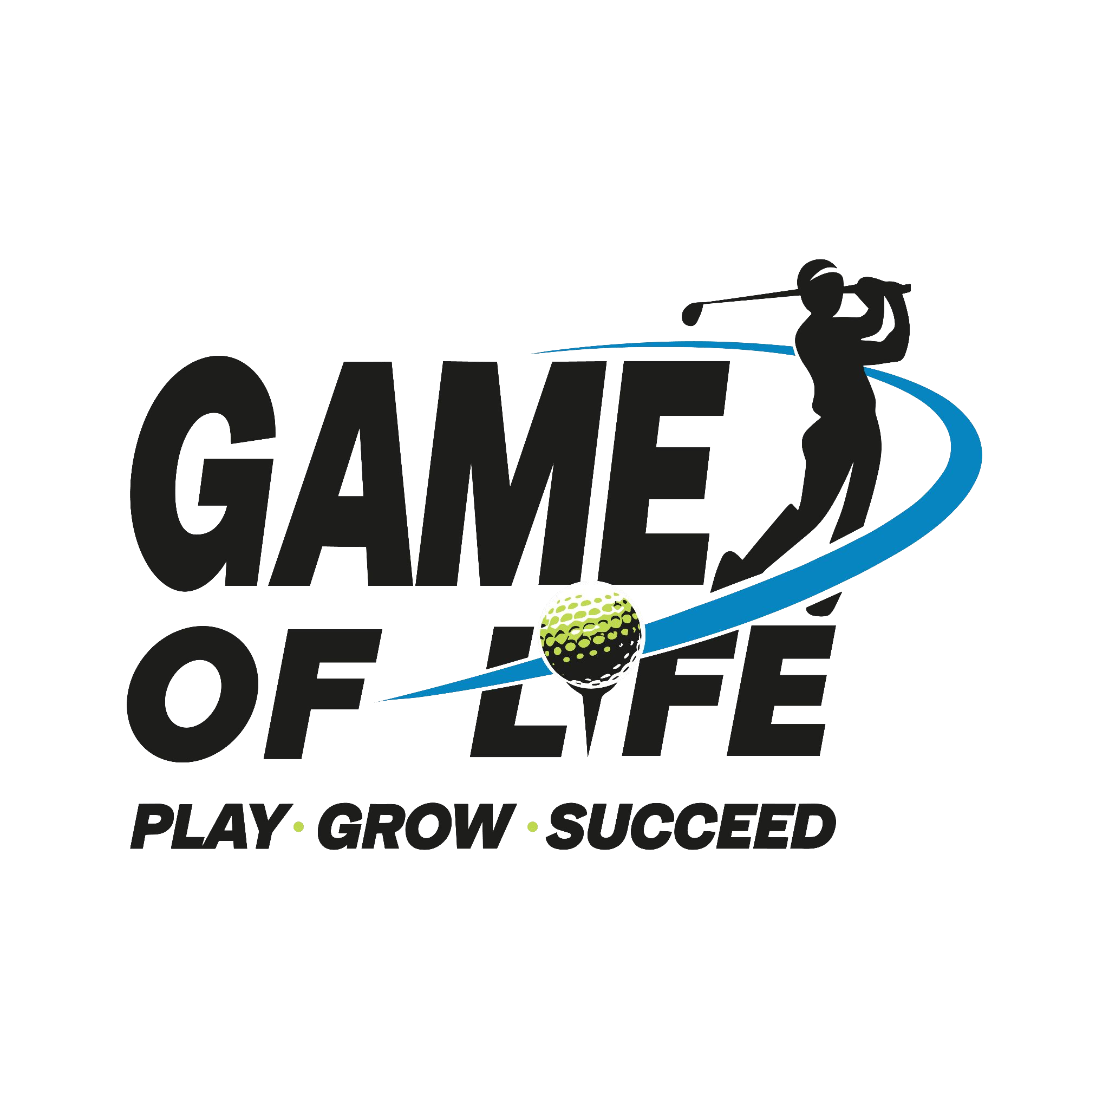

FORMAT | “Relive the Rivalry” — a 2-team invitational built around the school rivalry between Dipsite Falcons and Modern Eagles.  - Promoted & managed jointly by Game of Life Sports and Sports Boulevard  - 2 teams, unique head-to-head format (not a multi-team league like QGL or Alma Mater)
TOURNAMENT DETAILS | Wednesday, 1st October 2025 | Shotgun 12:30 PM  - Field Size — 100 participants  - Prize Ceremony — 6:00 PM · Gala Night — 7:00 PM onwards  - Venue — Qutab Golf Course, New Delhi
AUDIENCE PROFILE | - Median age 35+ (97% male attendees) · Avg. disposable income INR 75 lakh+  - Occupation: C-suite, senior management mix, entrepreneurs, defence and bureaucrats  - Residence: Delhi NCR  - Lifestyle: 50 lakh+ automobile owners, Amex/Citi Gold cardholders, elite golf club members, posh localities, alumni of top Delhi schools
MEDIA COVERAGE | No PR or media coverage identified in materials reviewed to date.
CURRENT SPONSORS | No sponsor names confirmed in the deck — the sponsorship section presents open tiers/categories only, no signed brands.
SPONSORSHIP RATE CARD (2025) | Title Sponsor — INR 10 Lakhs + GST (1 slot)  - Naming rights · 4 playing slots · logo on prize backdrop, tee boards, bag tags, scorecard & goodie bags · 6 runner boards · on-site activation stall · 4 Instagram posts · registration page & emailer  Gold Sponsor — INR 5 Lakhs + GST (2 slots)  - 2 playing slots · logo on prize backdrop, tee boards, bag tags & goodie bags · 3 runner boards · on-site activation stall · 2 Instagram posts  Silver Sponsor — INR 3 Lakhs + GST (3 slots)  - 1 playing slot · entrance arch logo · 2 runner boards · thank-you emailer  Sold/open status not stated in materials — confirm directly before outreach.
KEY DIFFERENTIATOR | Rivalry-driven narrative (Dipsite Falcons vs. Modern Eagles, #ReliveTheRivalry) distinct from GOLS's multi-team league properties — positions sponsors against a single, headline head-to-head format.
CONTACT | titanscup@golsports.in
Sources: Titans Cup Invitational 2025 Sponsorship Proposal (user-provided PDF).

